Artists’ Depiction of the Trinity
Student’s Name
Institutional Affiliations

Artists’ Depiction of the Trinity
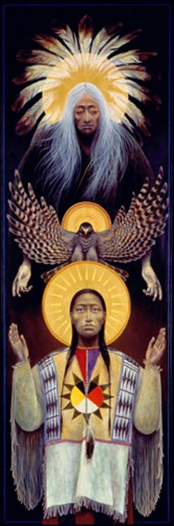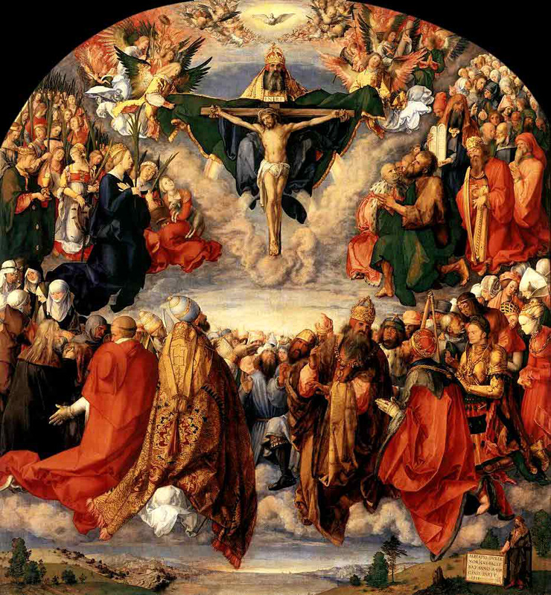
The two artists’ works have depicted the Trinity in different ways. In the first image, painted by Father John Giuliani, depicts the trinity based on the native’s perspective. In the painting, the artist has depicted Father God, as the elder, who bends over his son. The son was raised as a priest. He is expected to take power under the Great Spirit pictured in the form of a red hawk. The painting is unlike what I understand about the Trinity in the sense that in the first Image, it seems that the Trinity is depicted as a hierarchical manifestation of spiritual power. The second painting shows Jesus on the cross, on top of him is God the Father, and the white doves in the air representing the Holy Spirit. However, paintings depict one thing that I understand; that the Trinity consists of three persons, God the father, God the son, and God the Holy Spirit. Therefore, the second image is in agreement with my understanding of Trinity because I can see the manifestation of the three elements of the Trinity which are God the Father, God the Son, who is Jesus Christ on the Cross and God the Holy Spirit, represented by the holiness of the place as depicted by people kneeling down and praying to The Father and the Son through the help of the existence of the Holy Spirit around them. Even though Giuliani’s painting may have a different interpretation based on the native’s perspectives, but I believe that it supports the three aspects of Trinity.
However, both pictures depict the existence of the three important elements in understanding God, who exists in three forms. Therefore, the understanding of the existence of the Trinity is illustrated by the artist in both pictures by showing the three forms of God's existence.

